**IST659 – Data Admin Concepts & Db Mgmt**

**Lab 7 - Ramasamy Seenivasagamani – Sanjeev**

**1. Views: create views based on the following requirements**

**a) interviews_summary: for all the candidates, find their interviews and the**

**corresponding interviewers. This view should show the candidate ID, candidate**

**name, interview ID, interviewer ID, and interviewer name.**

CREATE VIEW INTERVIEWS_SUMMARY AS

select c.CandidateId, c.CFName,c.CLName, i.InterviewId, i1.InterviewerId, i1.IFName, i1.ILName from Candidate c

join

Interview i on c.CandidateId=i.CandidateId

join

Interviewer i1 on i.InterviewerId=i1.InterviewerId

SELECT * FROM INTERVIEWS_SUMMARY

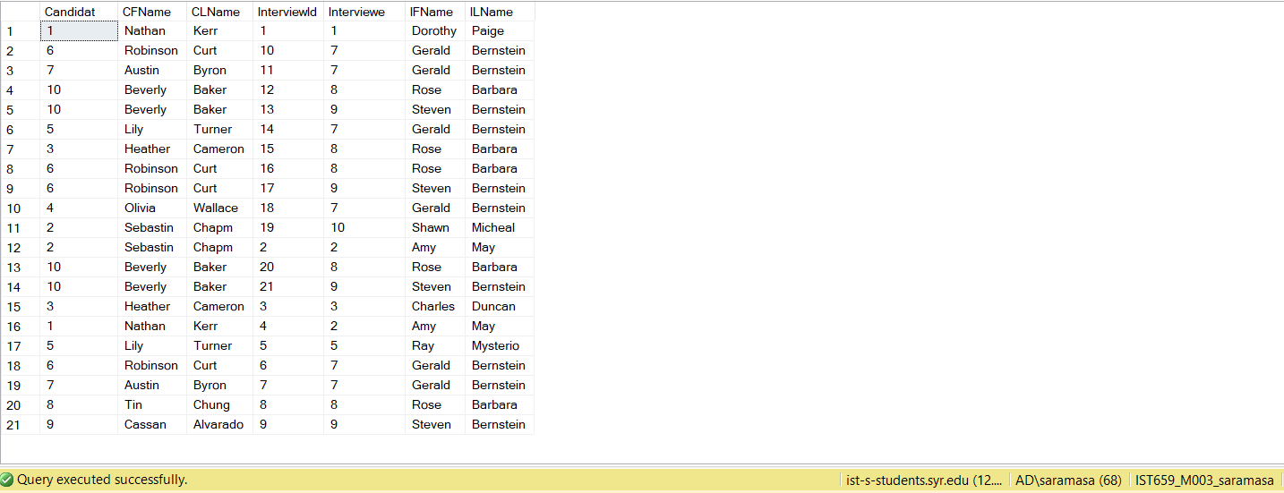

**b) position_summary: find the total number of positions available for each company in**

**the second half of 2013 (Jul, Aug, Sep, Oct, Nov, Dec).**

CREATE VIEW POSITION_SUMMARY AS

SELECT c.CompanyId, c.CompanyName, count(p.PositionId) as Number_of_Positions FROM Position p

join Interview i on p.PositionId=i.PositionId

join Company c on p.CompanyId=c.CompanyId

WHERE i.InterviewDate between '2013-07-01' and '2013-12-31'

GROUP BY c.CompanyId, c.CompanyName

select * from POSITION_SUMMARY

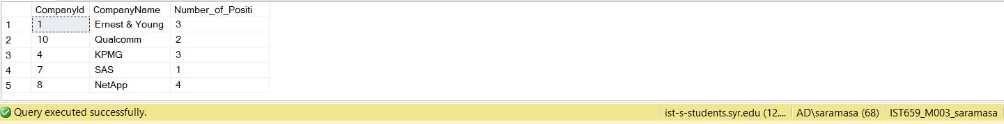

**c) maximum_candidate_interview_summary: find the candidate who had the largest**

**number of interviews.**

create view maximum_candicate_interview_summary as

select c.CandidateId, CFName, CLName, count(InterviewId) as Number_of_Interviews

from Candidate c

join

Interview i on c.CandidateId=i.CandidateId

group by c.CandidateId, CFName, CLName

having count(InterviewId)= (select max(abc.cnt) from (select c.CandidateId , c.CFName, c.CLName,count(InterviewId) as cnt from Interview i

join

Candidate c on i.CandidateId=c.CandidateId

group by c.CandidateId,c.CFName, c.CLName) as abc)

select * from maximum_candicate_interview_summary



**d) minimum_interviewer_prescription_summary: find the interviewer who had the**

**lowest number of interviews.**

create view minimum_interviewer_prescription_summary as

select i2.InterviewerId, i2.IFName, i2.ILName, count(InterviewId) as Number_of_Interviews

from Interviewer i2

left join

Interview i on i.InterviewerId=i2.InterviewerId

group by i2.InterviewerId, i2.IFName, i2.ILName

having count(InterviewId)= (select min(cnt) from (select count(InterviewId) as cnt from Interview i

right join

Interviewer i2 on i2.InterviewerId=i.InterviewerId

group by i2.InterviewerId) as abc)

select * from minimum_interviewer_prescription_summary



**e) position_interview_summary: find the position for which the largest number of**

**interviews were conducted.**

create view position_interview_summary as

select p.PositionId, p.PositionName, count(InterviewId) as Number_of_Interviews

from Position p

join

Interview i on p.PositionId=i.PositionId

group by p.PositionId, p.PositionName

having count(InterviewId)= (select max(abc.cnt) from (select count(InterviewId) as cnt from Interview i

join

Position p on p.PositionId=i.PositionId

group by p.PositionId) as abc)

select * from position_interview_summary



**2. Create two transactions:**

**a) Create a new interview for a new candidate. New rows should be inserted into the**

**tables Candidate, Interview, and Position.**

**Step 1: create a new candidate record whose first name is “Shah”, last name is**

**“Kantilal”, and phone number is “315-525-2552”. His address is “193 Lancaster Ave,**

**Syracuse, New York, 13210”. Candidate experience is in “Database and**

**Development” and Relevant Experience is in “Database Administration”. He was**

**interviewed on “2013-11-08 00:00:00.000” for his 1st round of interview for**

**“Database Developer” position at Google. Position level is “Entry” and position is**

**available. His interviewer was “Rose Barbara”.**

**Step 2: display records from Candidate, Interview, and Position table.**

**Step 3: ROLLBACK transaction.**

**Step 4: display records from Candidate, Interview, and Position table.**

BEGIN TRANSACTION

--Candidate

insert into Candidate (CandidateId,CFName,CLName,CPhone,CStreetno,CStreetName,CCity,CState,CZip,CExperience,CRelevantExp)

values (11,'Shah','Kantilal','315-525-2552',193, 'Lancaster Ave', 'Syracuse','NY', 13210, 'Database, Development','Database Administration');

--Position

--PositionId varchar(20), PositionName , PositionLevel , PositionAvailable , CompanyId ,

insert into Position values(13,'Database Developer','Entry','yes',6);

--Interview Table

--InterviewId varchar(20),RoundNumber InterviewDate , CandidateId , InterviewerId ,PositionId ,

insert into Interview values(22,1,'2013-11-08 00:00:00.000',11,8,13);

select * from Candidate

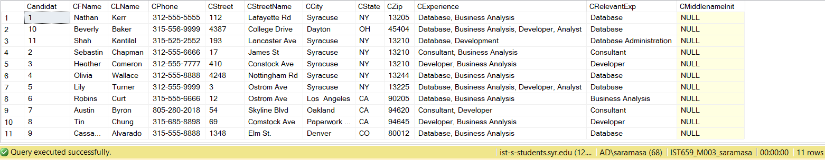

select * from Interview

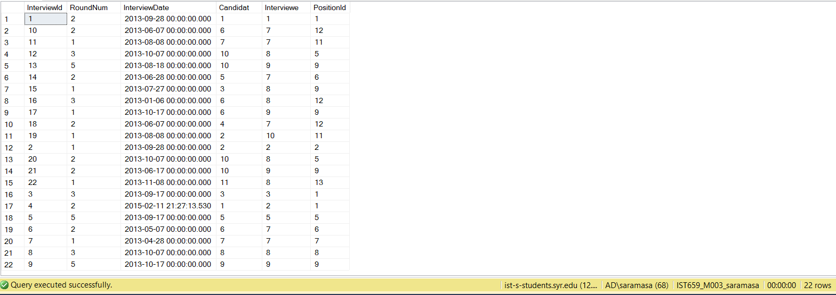

select * from Position

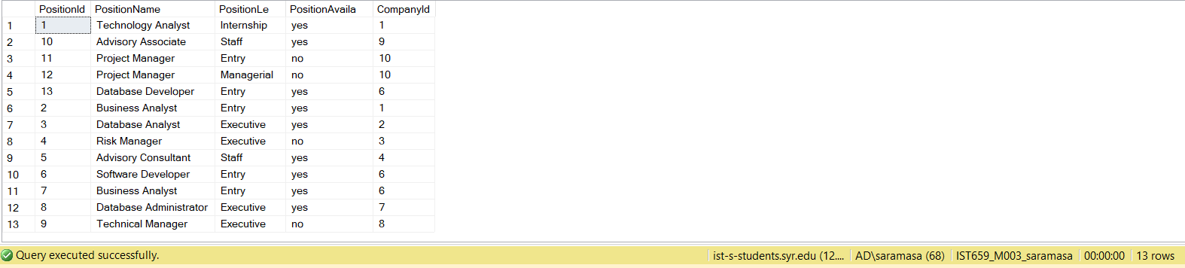

rollback

select * from Candidate

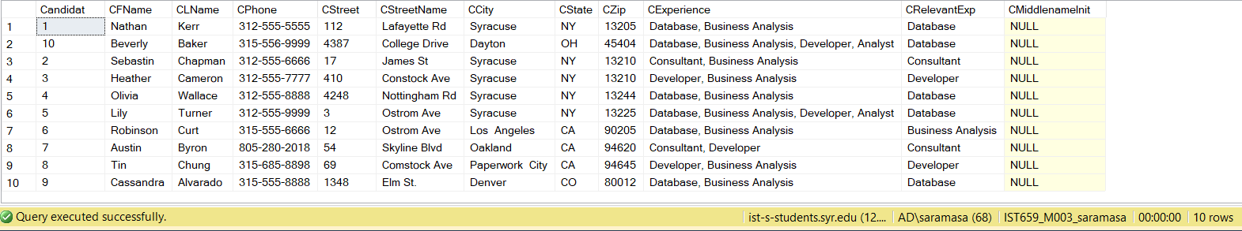

select * from Interview

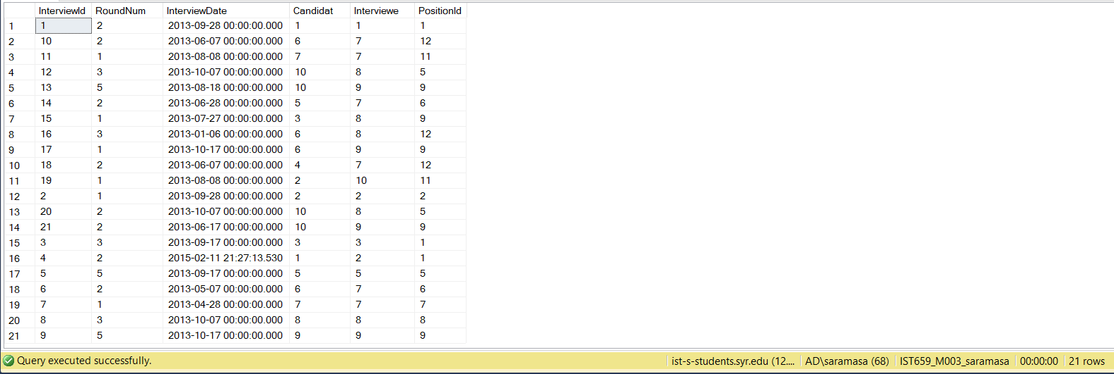

select * from Position

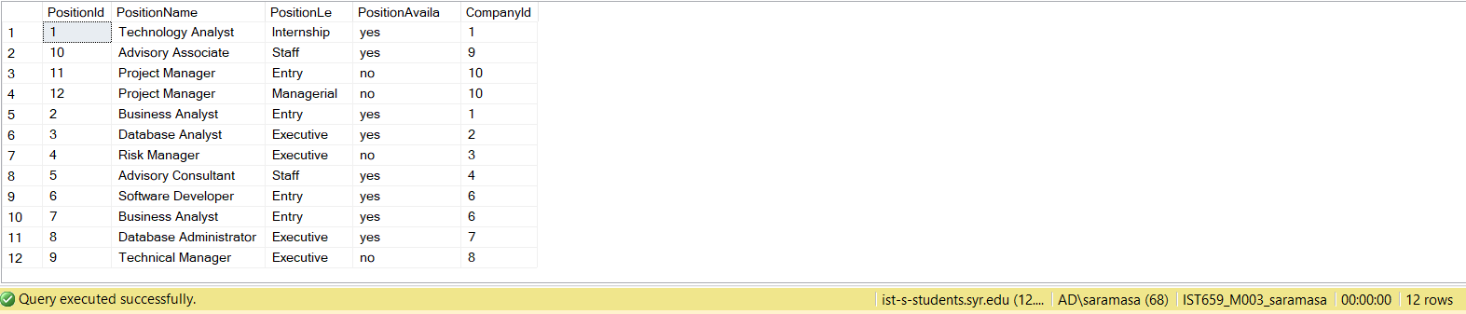

**b) Add a new position for a company. New rows should be inserted into the tables**

**Company, Position and Interview.**

**Step 1: create a new record for the company “Apple”. The company has a website**

**URL www.apple.com and company phone is “400-000-1212”. Company**

**Headquarters’ address is “1 Infinite Loop Cupertino, CA 95014”. The position they**

**are hiring for is “Program Analyst” which is a “Staff” position. The 1st round of**

**interviews were conducted for 3 candidates on “2013-11-01 00:00:00.000”. The 3**

**candidates were “Sebastian Chapman”, “Lily Turner” and “Tin Chung”. Also the**

**interviewer was “Shawn Micheal”**

**Step 2: display records from Company, Position and Interview table.**

**Step 3: COMMIT transaction.**

**Step 4: display records from Company, Position and Interview table.**

Begin Transaction

insert into Company(CompanyId, CompanyName, CompanyPhone, Companywebsite, CoStreetNo, CoStreetName,CoCity, CoState, CoZip)

values (11, 'Apple', '400-000-1212', 'www.apple.com', 1, 'Infinite Loop Cupertino', 'California', 'CA', 95014);

--Position

--PositionId varchar(20), PositionName , PositionLevel , PositionAvailable , CompanyId ,

insert into Position values(13,'Program Analyst','Staff','yes',11);

--Interview Table

--InterviewId varchar(20),RoundNumber InterviewDate , CandidateId , InterviewerId ,PositionId ,

insert into Interview values(22,1,'2013-11-01 00:00:00.000',2,8,13);

insert into Interview values(23,1,'2013-11-01 00:00:00.000',5,8,13);

insert into Interview values(24,1,'2013-11-01 00:00:00.000',8,8,13);

commit

select * from Company

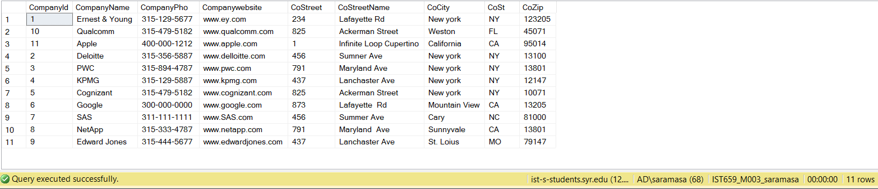

select * from Position

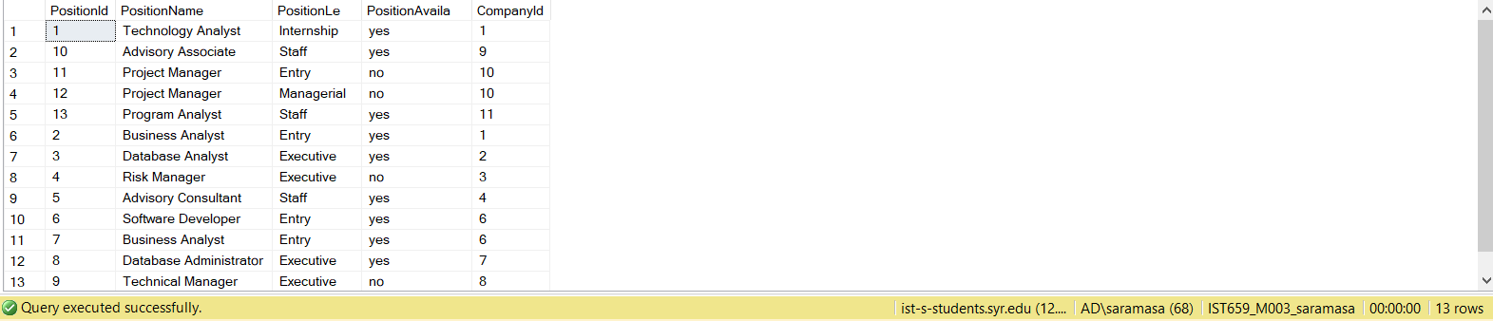

select * from Interview

